Stephen Leyland Swim Profile – evidence of cold water (1 Month)
Sunday December 4th 2022
https://connect.garmin.com/modern/activity/10083348844
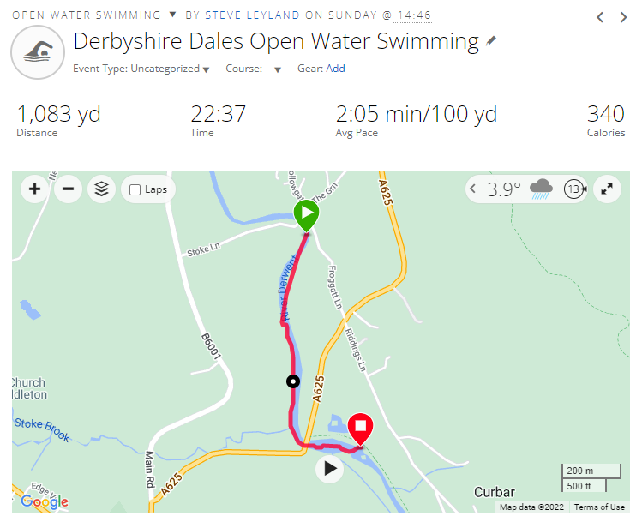
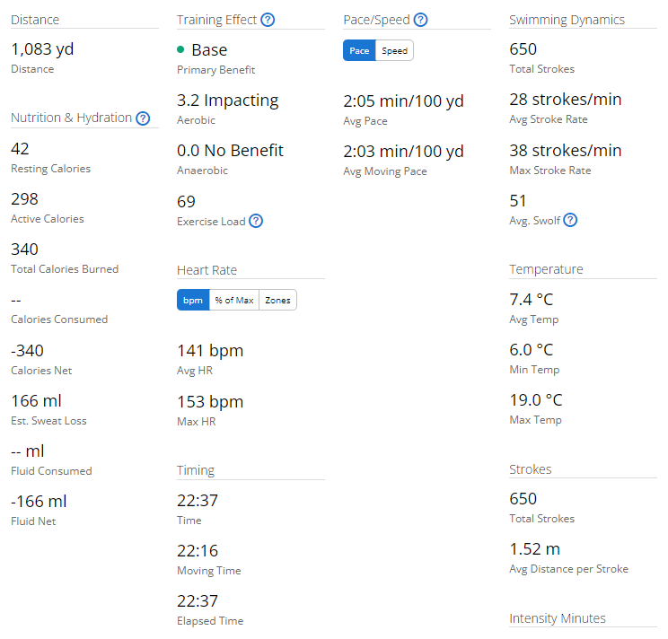
Friday 2nd December 2022
https://connect.garmin.com/modern/activity/10072360495
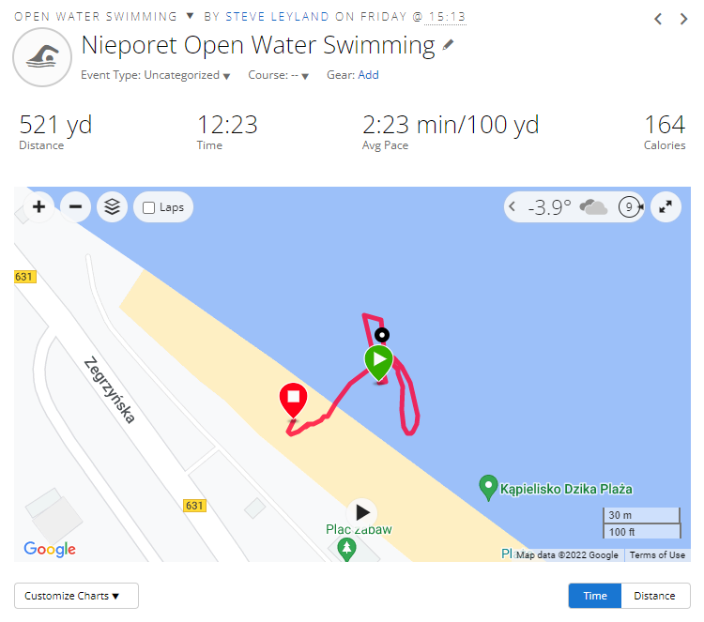
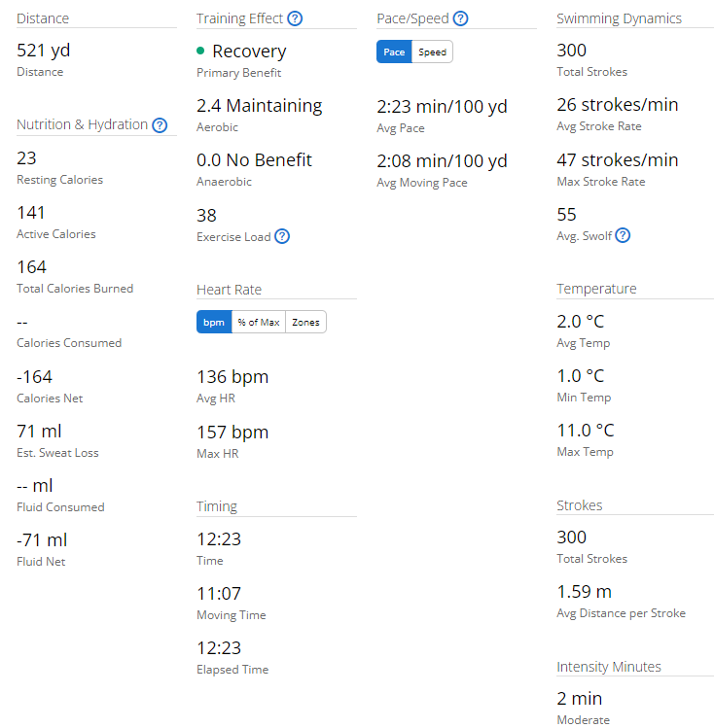

Sunday 20th November 2022
https://connect.garmin.com/modern/activity/10007597131
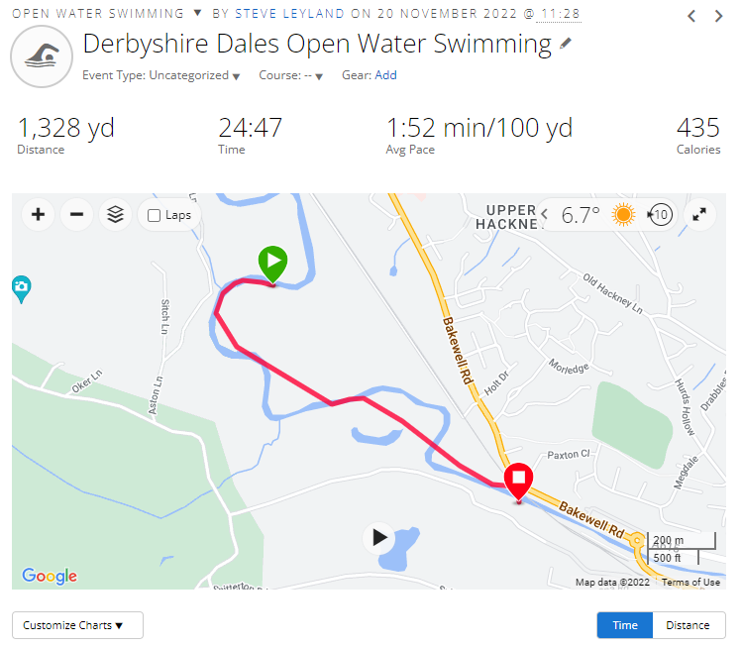

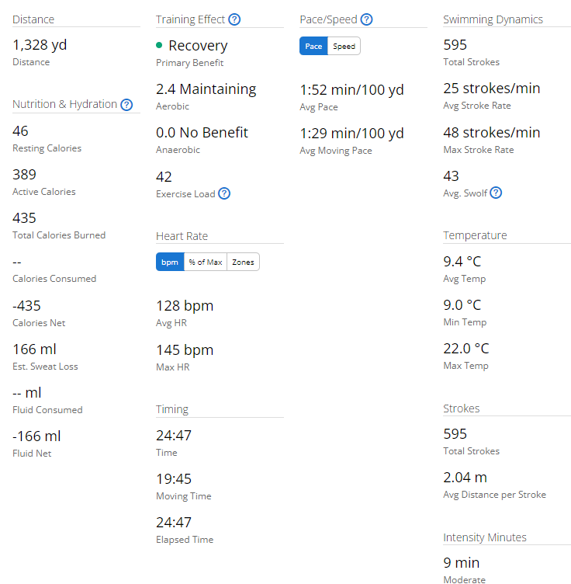

Saturday 19th November 2022 – Swim Your Swim
https://connect.garmin.com/modern/activity/10001445274
